Broke notes
Modelling the air transport with complex networks: A short review –
Massimiliano Zanin, Fabrizio Lillo
https://arxiv.org/abs/1302.7017
Quotations：
‘Another aspect of interest is the dynamics taking place on the network. A paradigmatic example, reviewed in this paper, is the spreading of infectious diseases worldwide and the role that air transport has in enhancing the speed of epidemic propagation.’
Even back at the 2013 researchers have noticed the potential risk of global pandemic spreading out through the aviation network.

‘Additionally, while complex networks are traditionally considered as static objects, it is clear that time is an important feature of any movement. This is especially true in the case of the air transport, because passengers may have to use several flights to get to their destination. If one considers only static representations of the network, there is no way of knowing the real dynamics of passengers, i.e., if one needs to wait 2 or 10 hours in a airport before taking the next connecting flight.’
This section shows that while most of airline networks don’t show time directly within the visual map, time remains an important factor when considering the connectivity of airlines’ network.

‘Another example of networks considers reactionary delays and their effect on passengers. These are situations in which a flight cannot take off on time because of a delay in another flight. This occurs, for instance, because of the late arrival of the aircraft, or of the crew itself. Different networks may be created to study this phenomenon. Nodes may represent crews, with a link between them when they share the same aircraft. Alternatively, nodes may also represent airports, connected whenever the same aircraft has to serve them in a sequential fashion. The identification of the central elements of these graphs may help in identifying which are critical points for the dynamics of the system, and would thus allow the creation of better mitigation strategies. To the best of our knowledge, this topic has not yet been studied within this framework.’
This shows the research on delay analysis has not yet been fully investigated due to the complexed elements involved in the calculation behinds it.

‘Point to point: in this configuration, a different aircraft serves each pair of airports in the network, or at least those pairs where the passengers’ demand is enough to justify the connection. While it has the advantage of offering direct connections to all passengers, it also requires a high number of aircraft for covering all the possible routes. For a completely connected network the number of connections increases with the square of the number of airports. This strategy of connections was common in the United States before the 70s deregulation , and nowadays is still used by several low-cost airlines.’
‘Hub-and-spoke: in this case, connections are structured like a chariot wheel (or a collection of such structures), in which all traffic moves along spokes connected to the hub(s) at the centre. While most passengers must take two different flights to reach their destination, this strategy presents several benefits for the airline. In fact, a lower number of aircraft is required, flights usually have a higher occupation rate, and the expansion of the network to a new airport only requires one new additional flight. Today the hub-and-spokes configuration is used by most major airlines all around the world’
These shows the major route network strategies that airline choose and the pros and cons behinds it.

‘On the short term, the network evolves to answer to the different needs of two groups of passengers, namely those moving for work and usually traveling from Monday to Friday, and those moving for leisure, traveling mainly during the weekend. It is well known that the first group is less sensitive to price, but highly values short travel durations. The result is that, during the week-end, the number of flights is reduced, and the network assumes a more star-like shape around the airports of cities of tourist interest.’
This shows how the airlines adapt to the different customers’ preferences by shifting their flights according to the days throughout the week.

‘On one side, it has been argued that the hub and spoke system increased airline’s efficiency and therefore, in a competitive market, it lead to lower prices. On the other side, it is clear that spoke cities risk being marginalized, being connected in a more indirect way to the rest of the system. The emergence of low cost carriers, thanks to the deregulation of the market, created cheaper opportunity of flying and created additional hub and spoke subnetworks, where hubs are different from the one used by main airlines’
This section shows that how different network plan decides the traveling availability. Most people only put their eyes on the major carriers, but low-cost airlines are playing in a crucial role in the air travel market. Their different network strategies give people from smaller places more chance to travel and let more people be able to fly.
‘Many papers have focused on the dynamics of the air transport network toward an higher spatial concentration, which means that the topology of the network becomes more and more similar to a collection of starlike structures.’
This part shows the network strategy trend of major airlines.

‘In a hub and spoke traffic network, airlines typically operate synchronized waves of flights through these hubs. The aim of such a wave-system structure is to optimize the number and quality of connections offered in the attempt to minimize waiting times for indirect connections.’
This part shows the timing strategy of how hub orientated airlines schedule their flight times in order to optimize their hub efficiency to reduce the transferring time of the passengers.

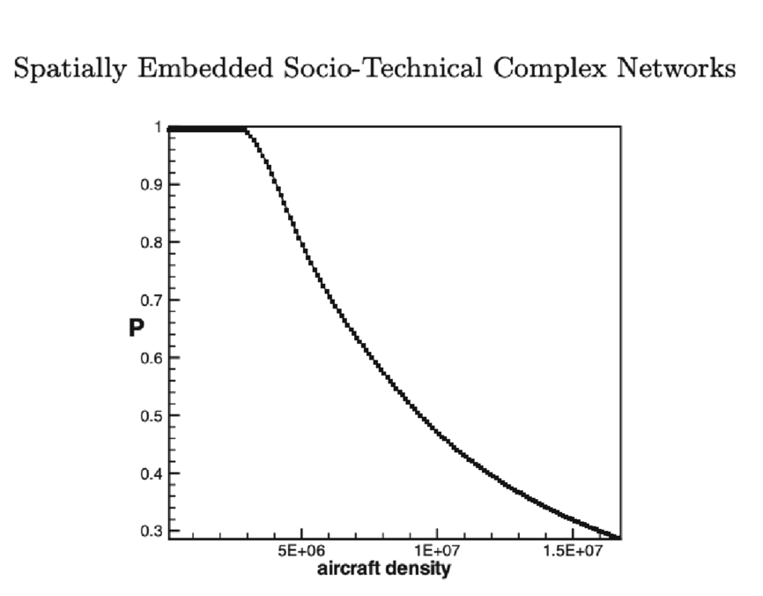
‘The key finding of Ref. [69] is that by increasing the aircraft density (number of aircraft), the system undergoes a phase transition. This is testified by the fact that the expected value of P sharply deviates from the efficient phase P = 1 when the aircraft density is larger than a threshold. After this threshold P declines, as expected. Correspondingly, the variance of P, goes abruptly from zero to an high value when the aircraft density is larger than the threshold described above. These and other evidence indicate that the system undergoes a jamming transition, similarly to what observed in other traffic systems’

This section shows the theoretical maximum aircrafts that an airline should put on a specific hub or route in a specific time, since more aircraft would lead higher risk of delay.

‘The de-activation of the 10% of the most connected airports is enough to reduce the topological efficiency [75] of the network of 25%.’
This part shows how the hub orientated networks can spread out delays easily when one hub occurs a ground stop.

